**There are**

**Index page**

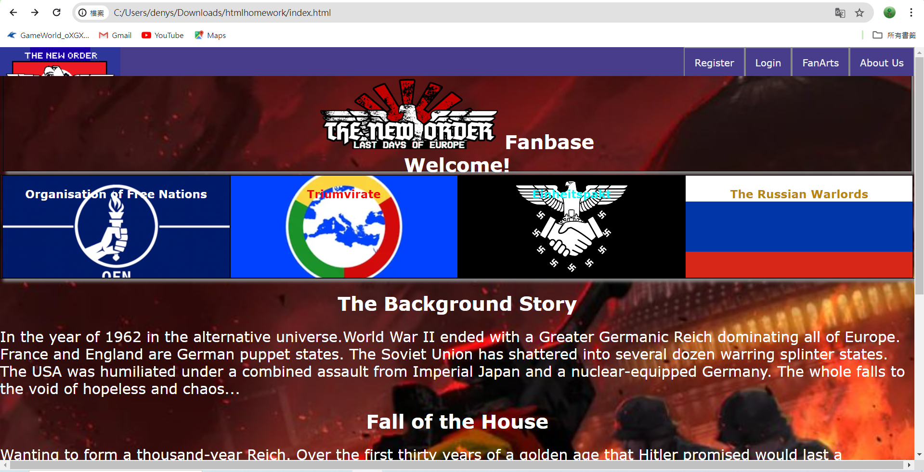

**Login Page**

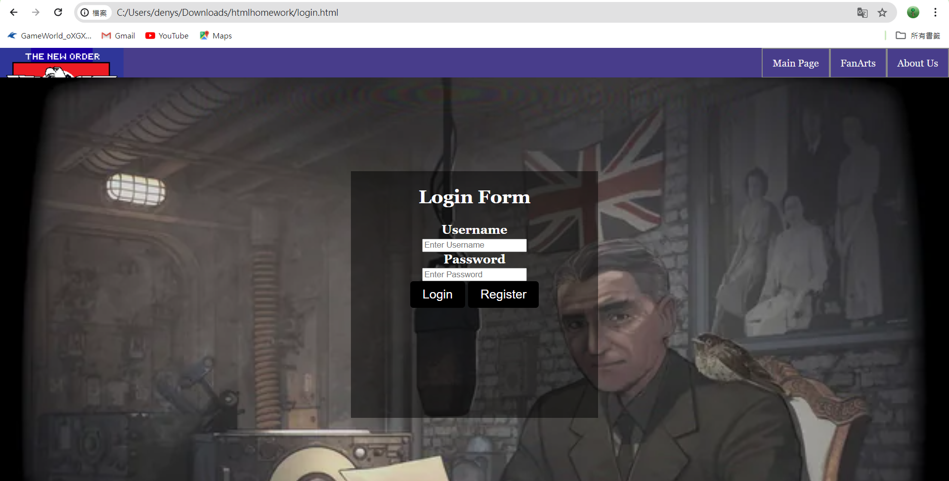

**Register Page**

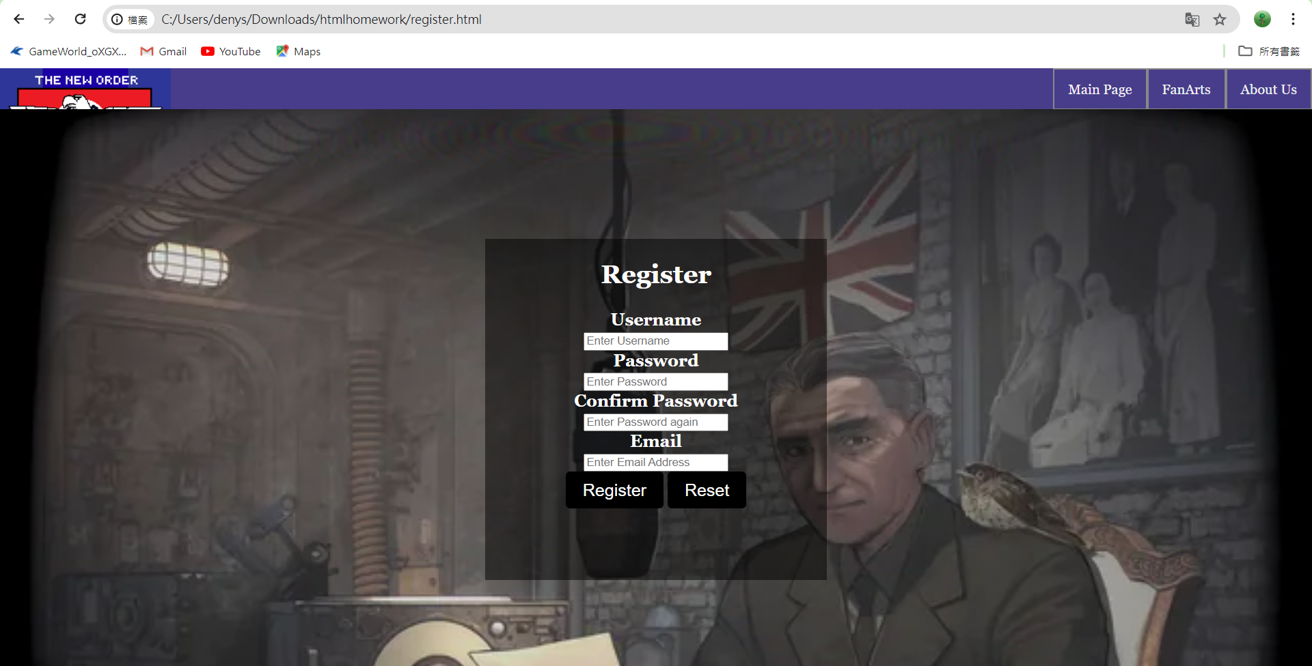

**Fan Arts page**

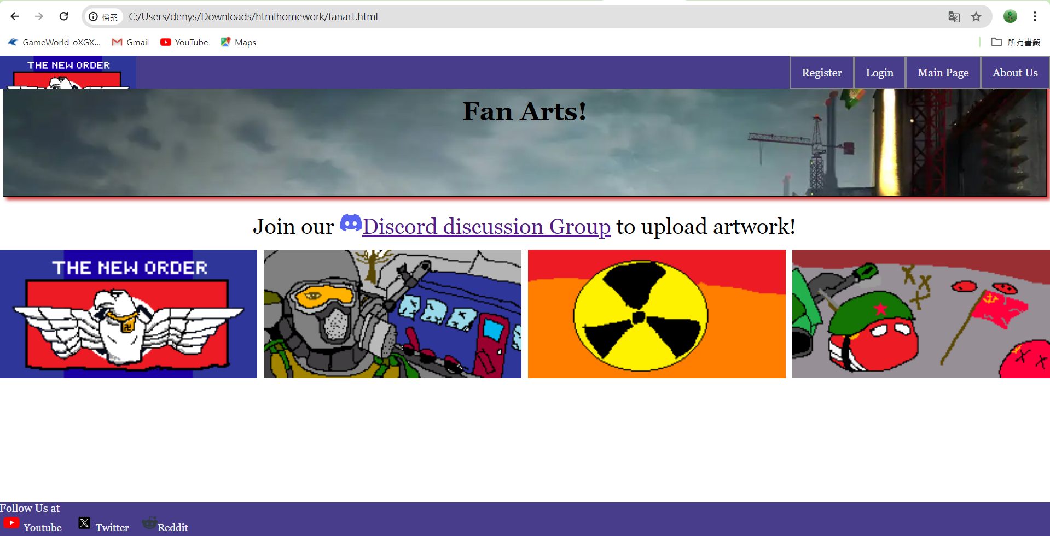

**About the club page**

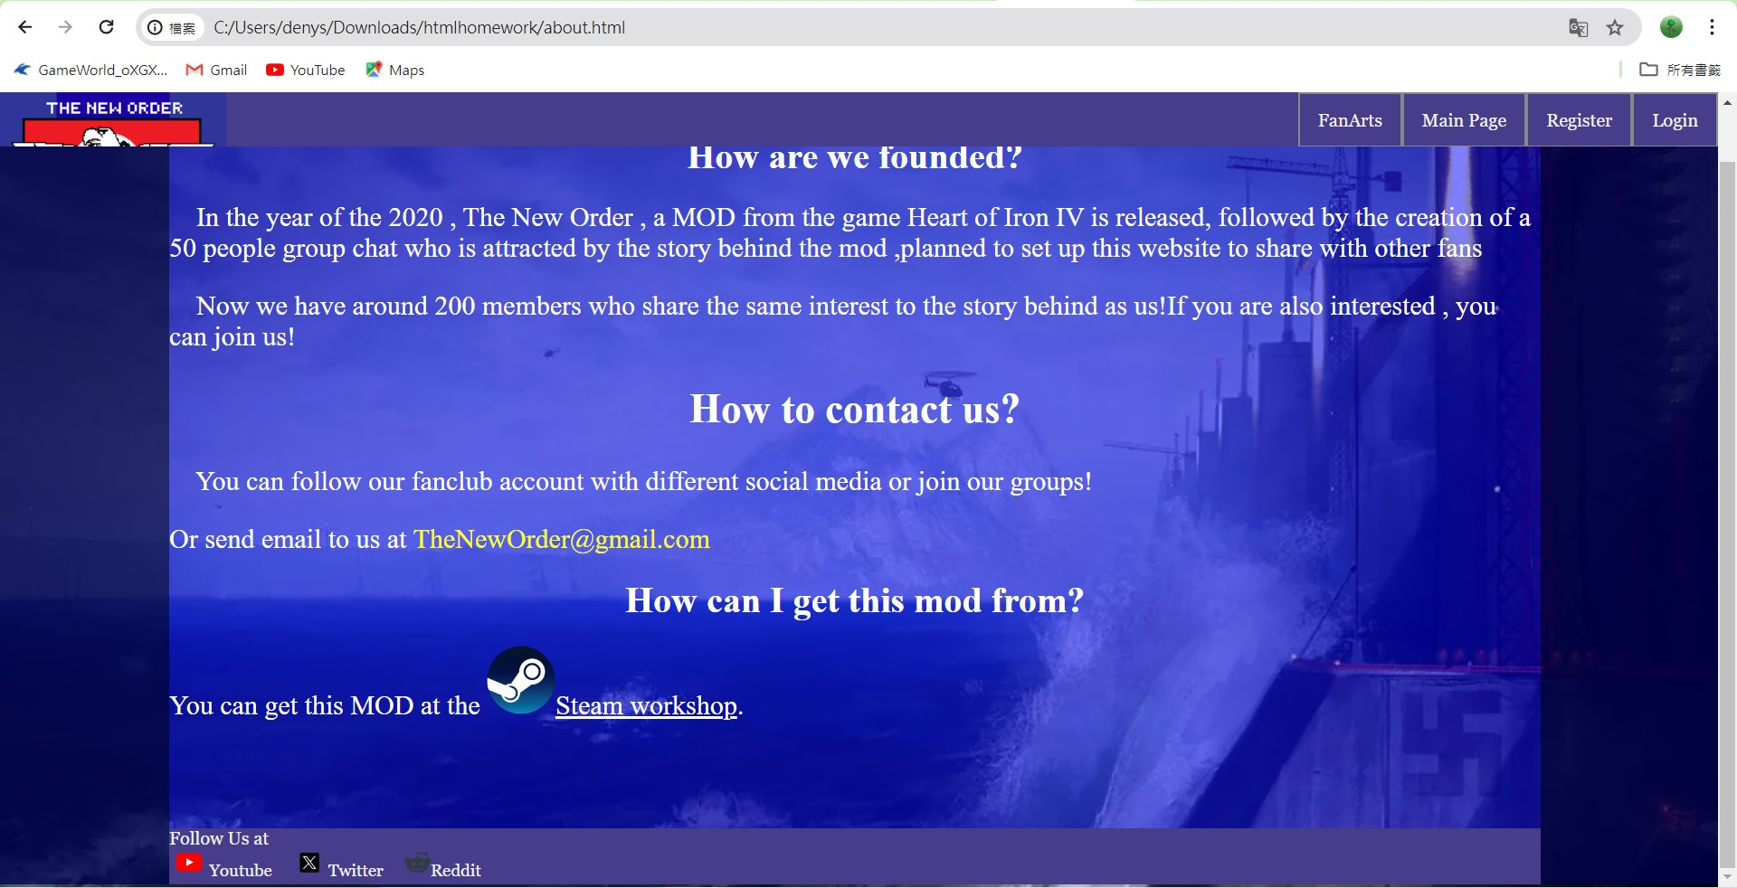

**And 4 different pages for every region/fraction**

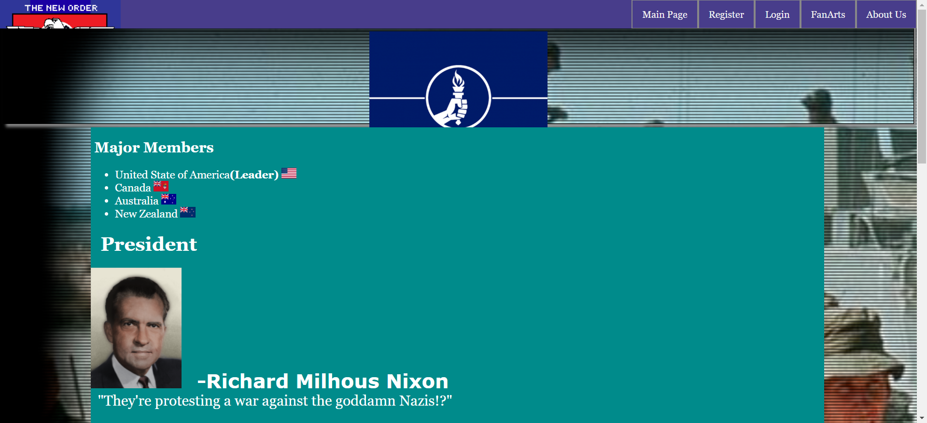

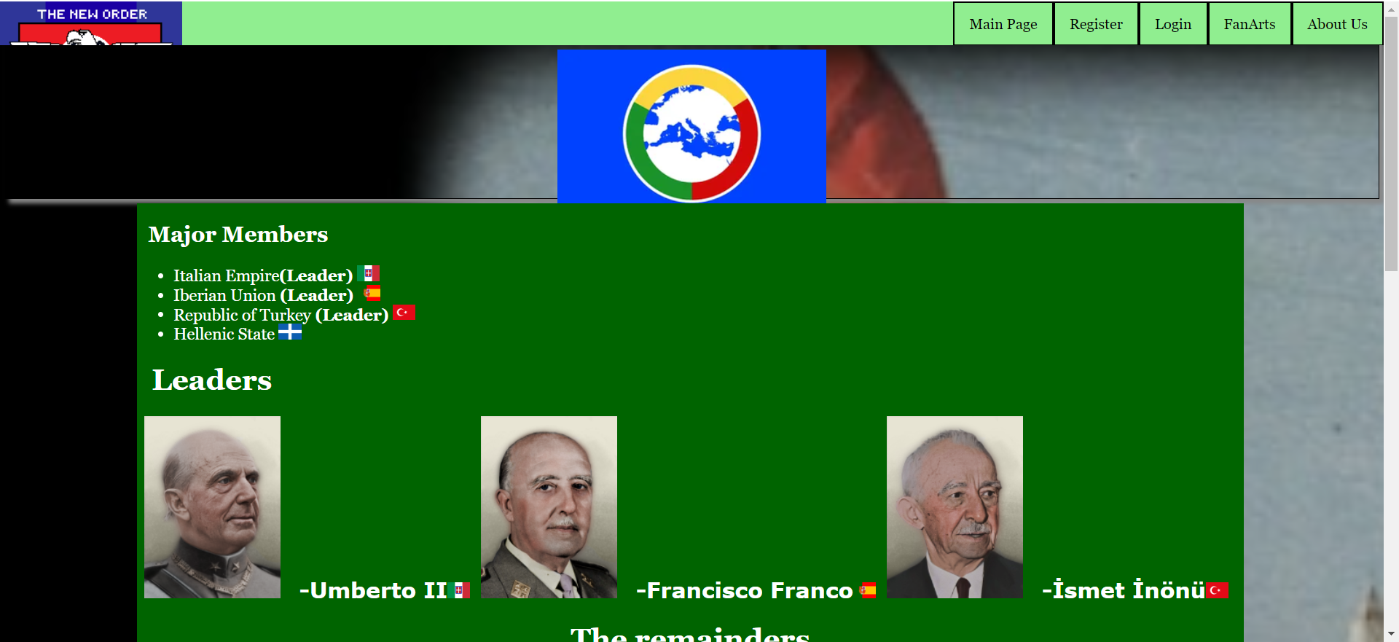

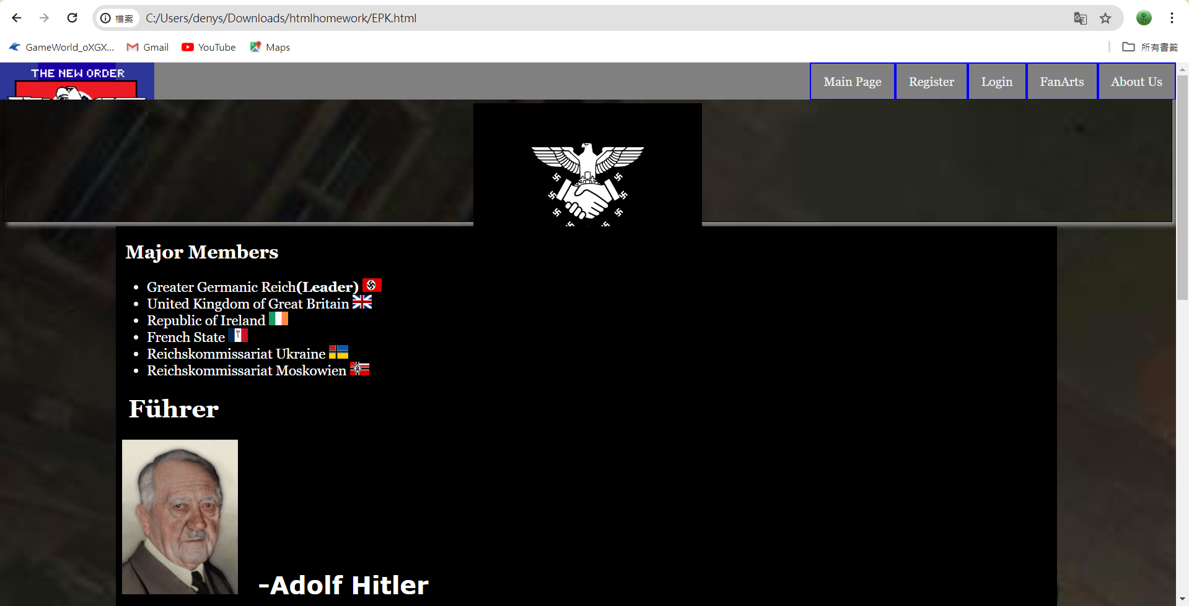

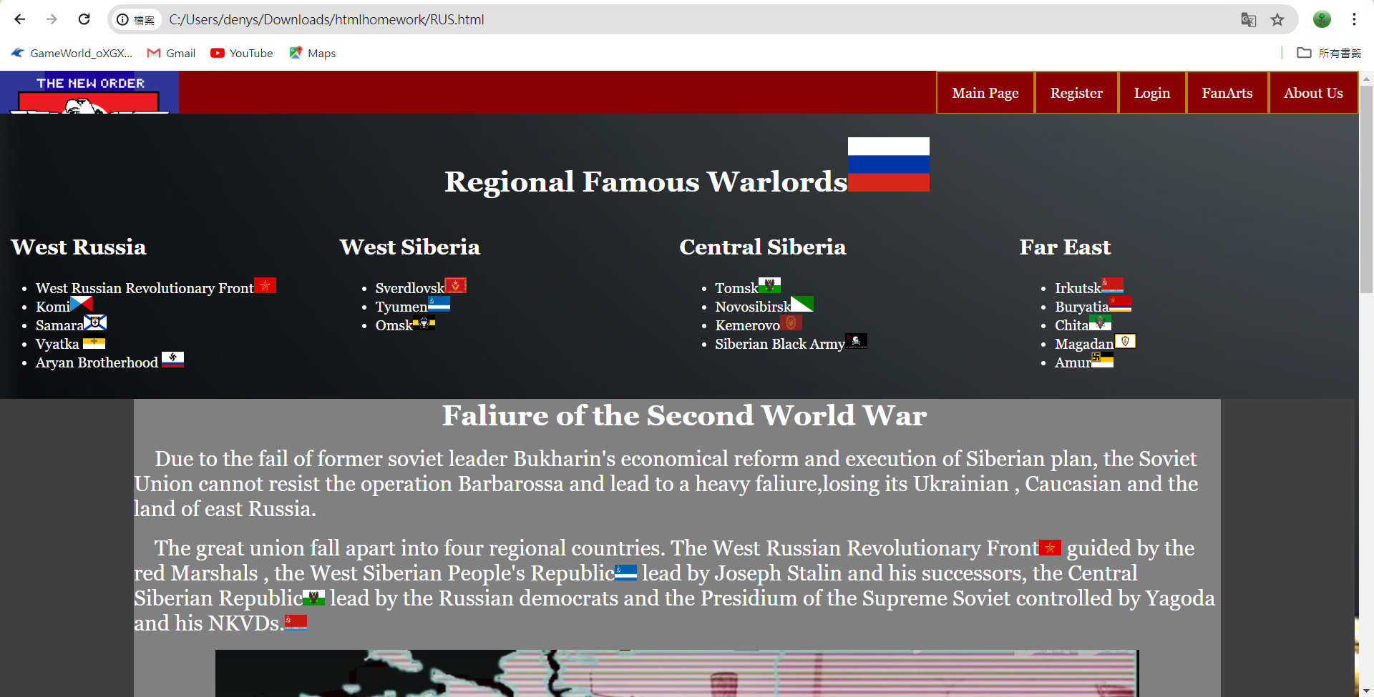

**This will explain how the website works.**

**The index page**

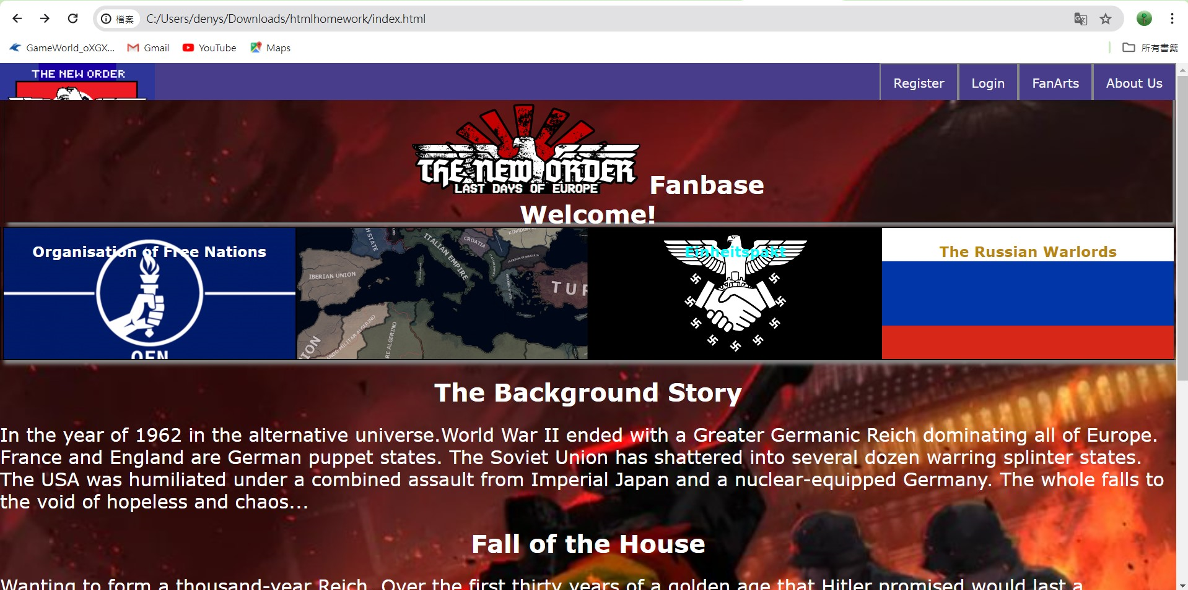

The bar with four regions or fractions will be changed in photo within 3 seconds to show their backgrounds , after click in you will be moved to the select page of the website .

For example

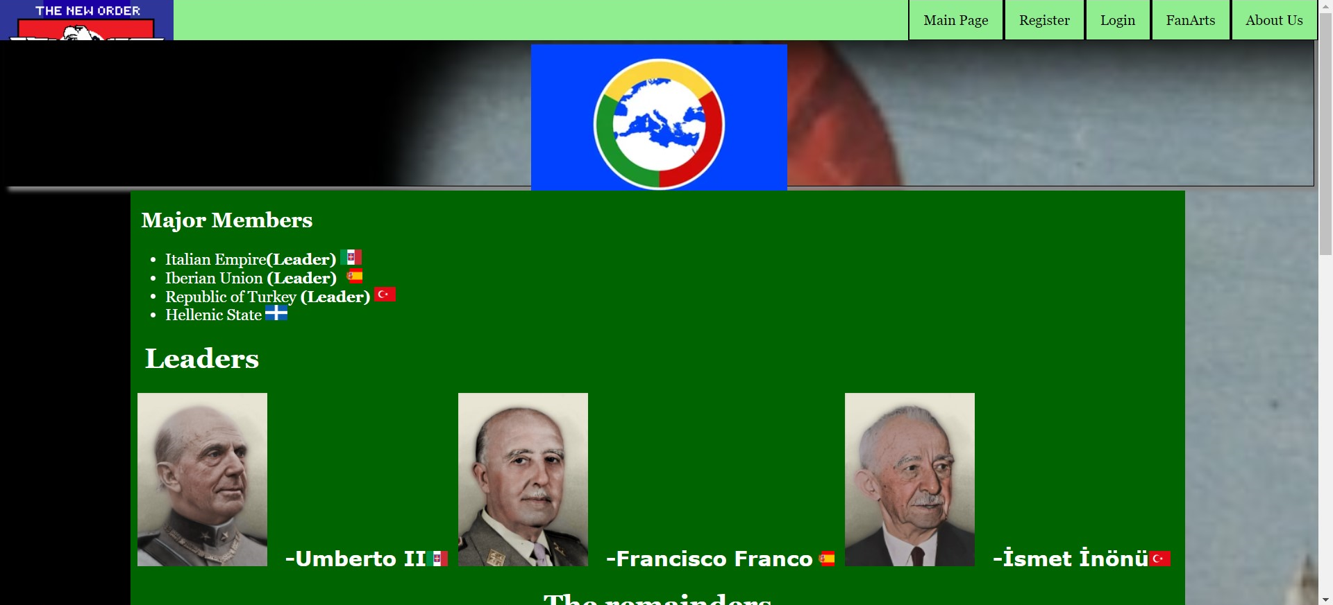

will be shown after clicking the Triumvirate fraction photo.

The top&bottom navigation bar will be changed in color depend on the region/ faction page

eg. Red for Russia

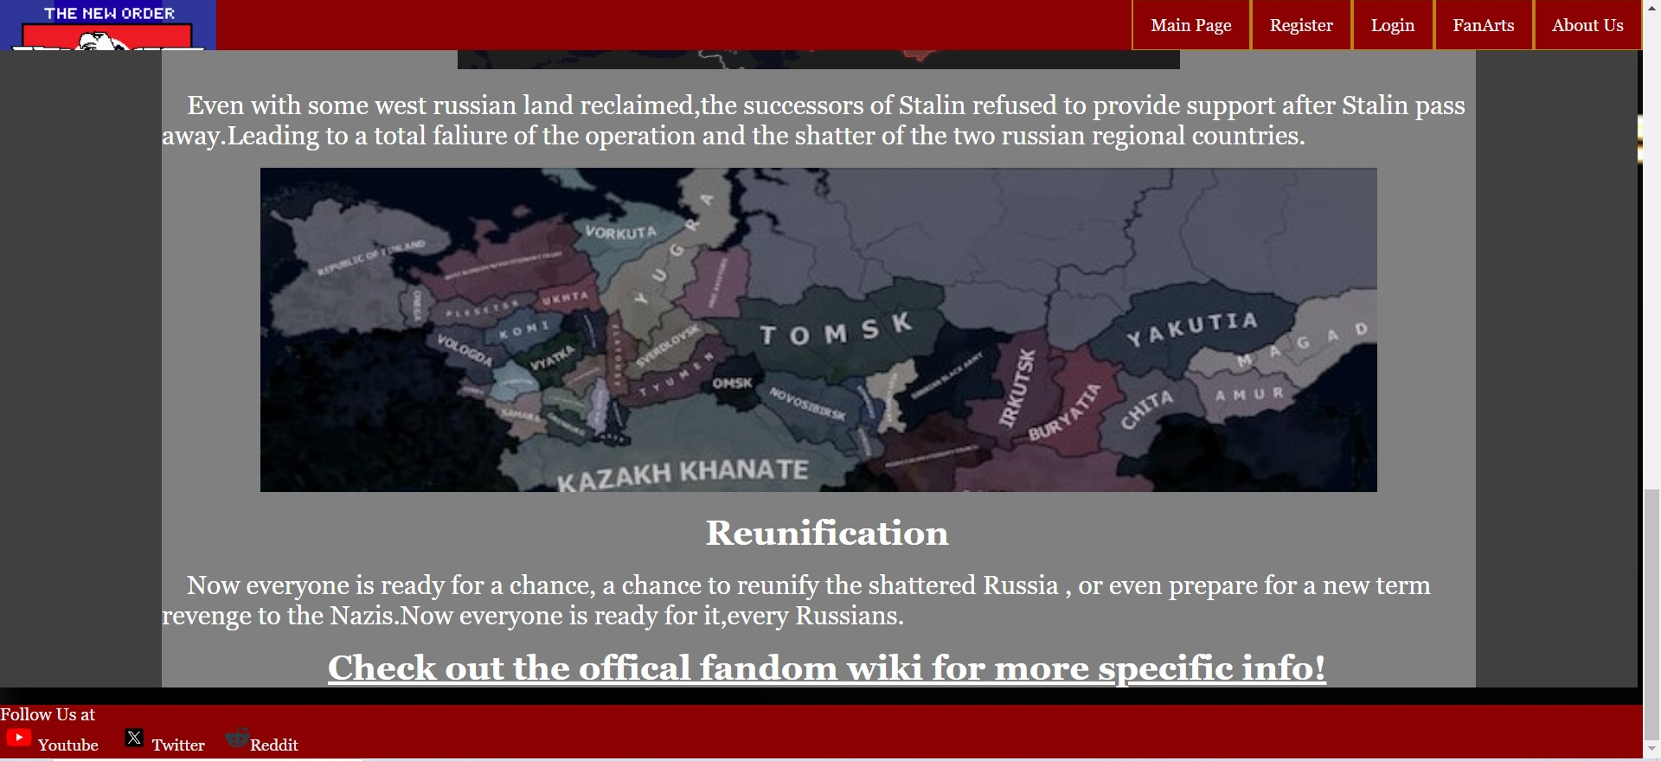

And gray for the Germany

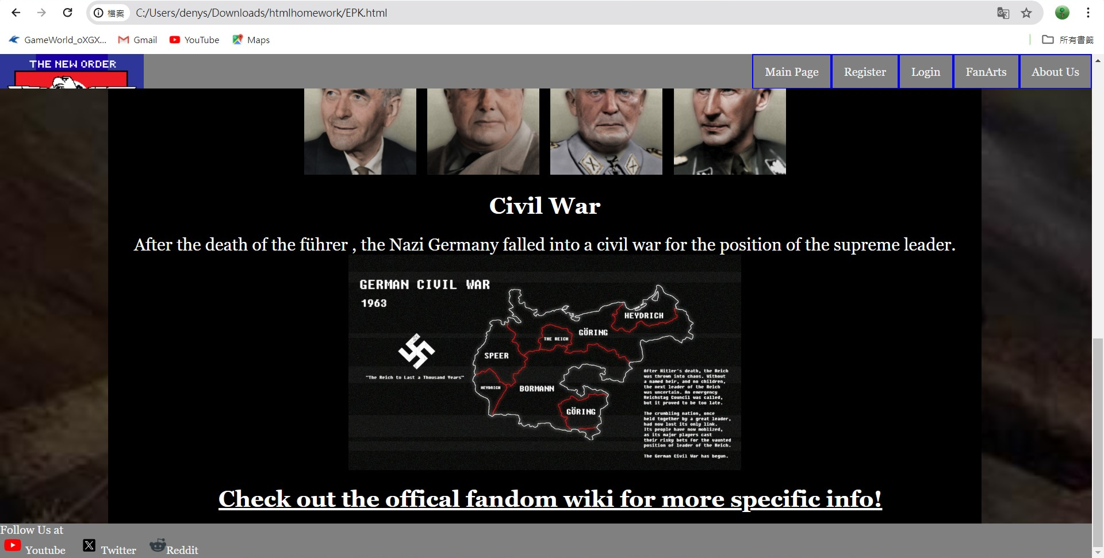

**The navigation bars**

Both navigation bars lead to a different web pages with the animation when the mouse pointer is over them

**Top navibar**

this can lead to the different page in website.E.g from index page to register page

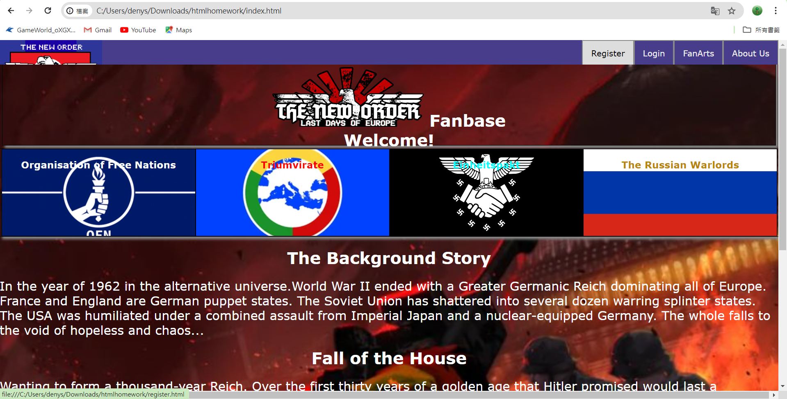

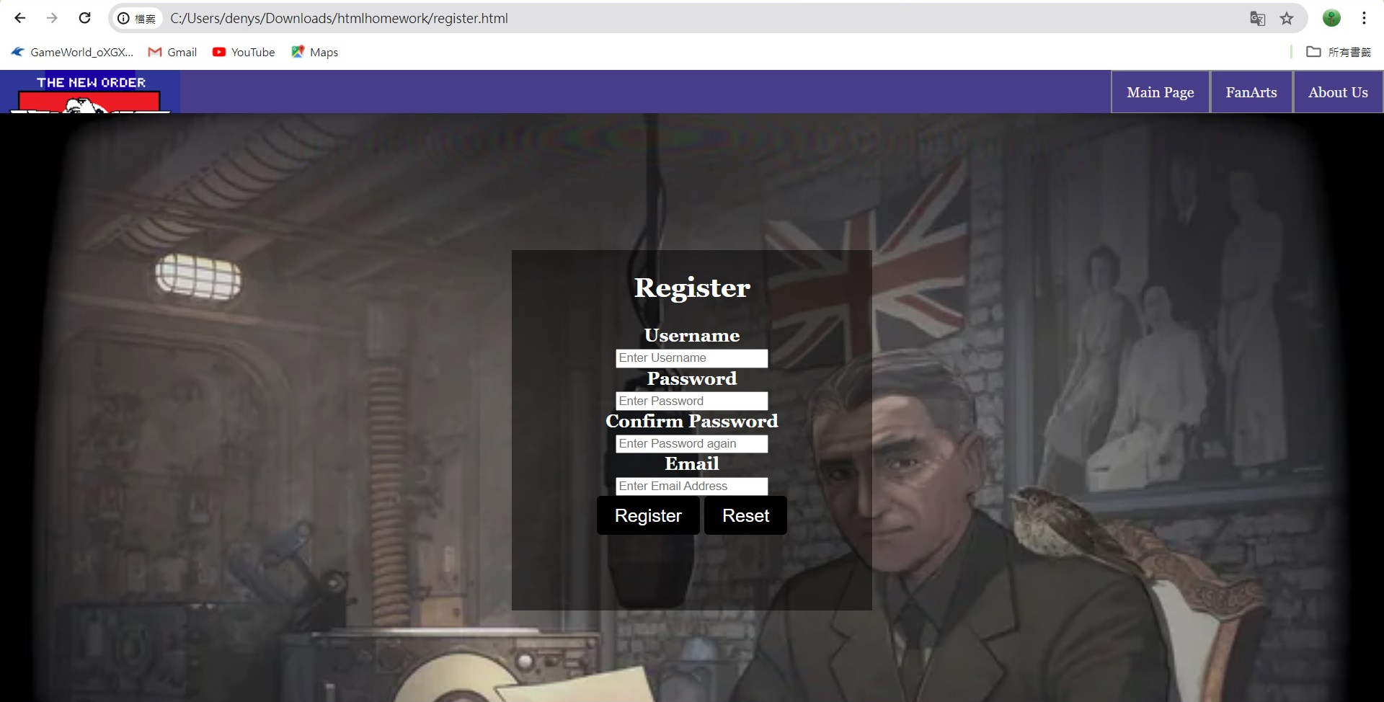

**Bottom navibar**

This bar leads to other websites of official accounts for follow

E.g. Index to official TNO Mod youtube account

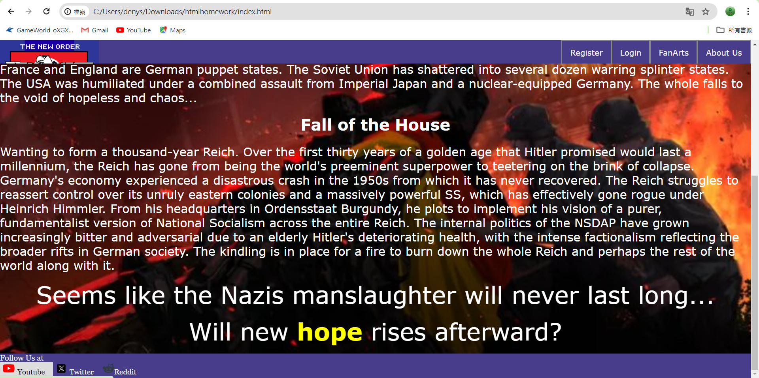

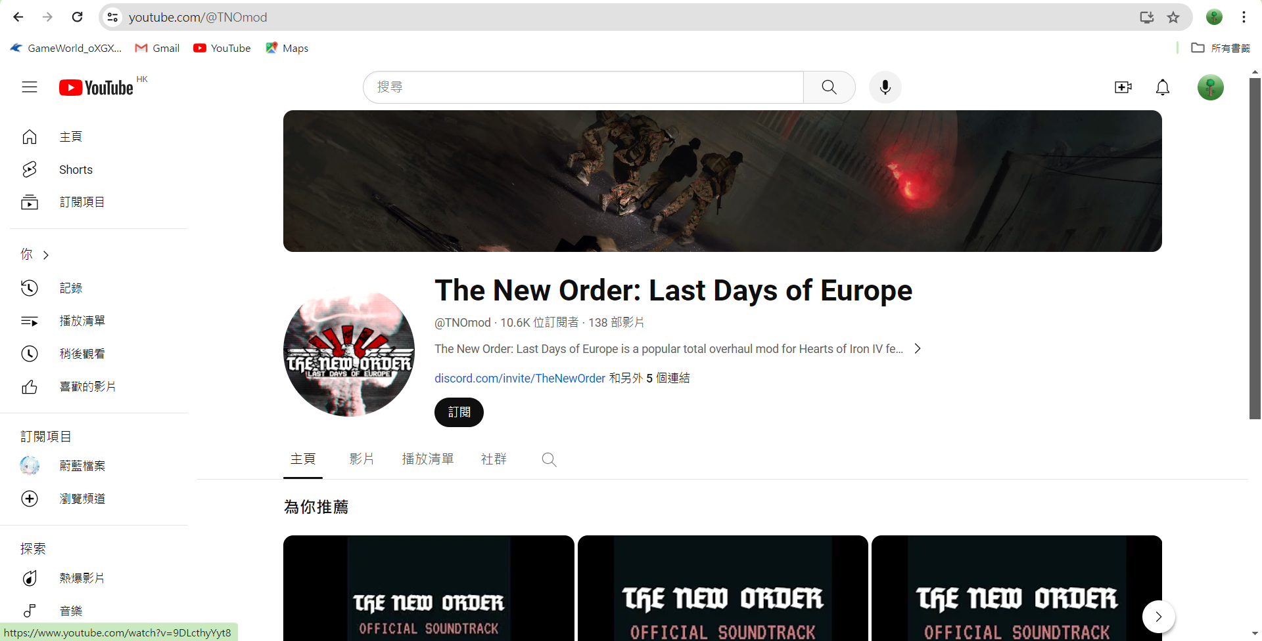

**Register Page**

The is checking for fields for the register page

For example:

Empty fields

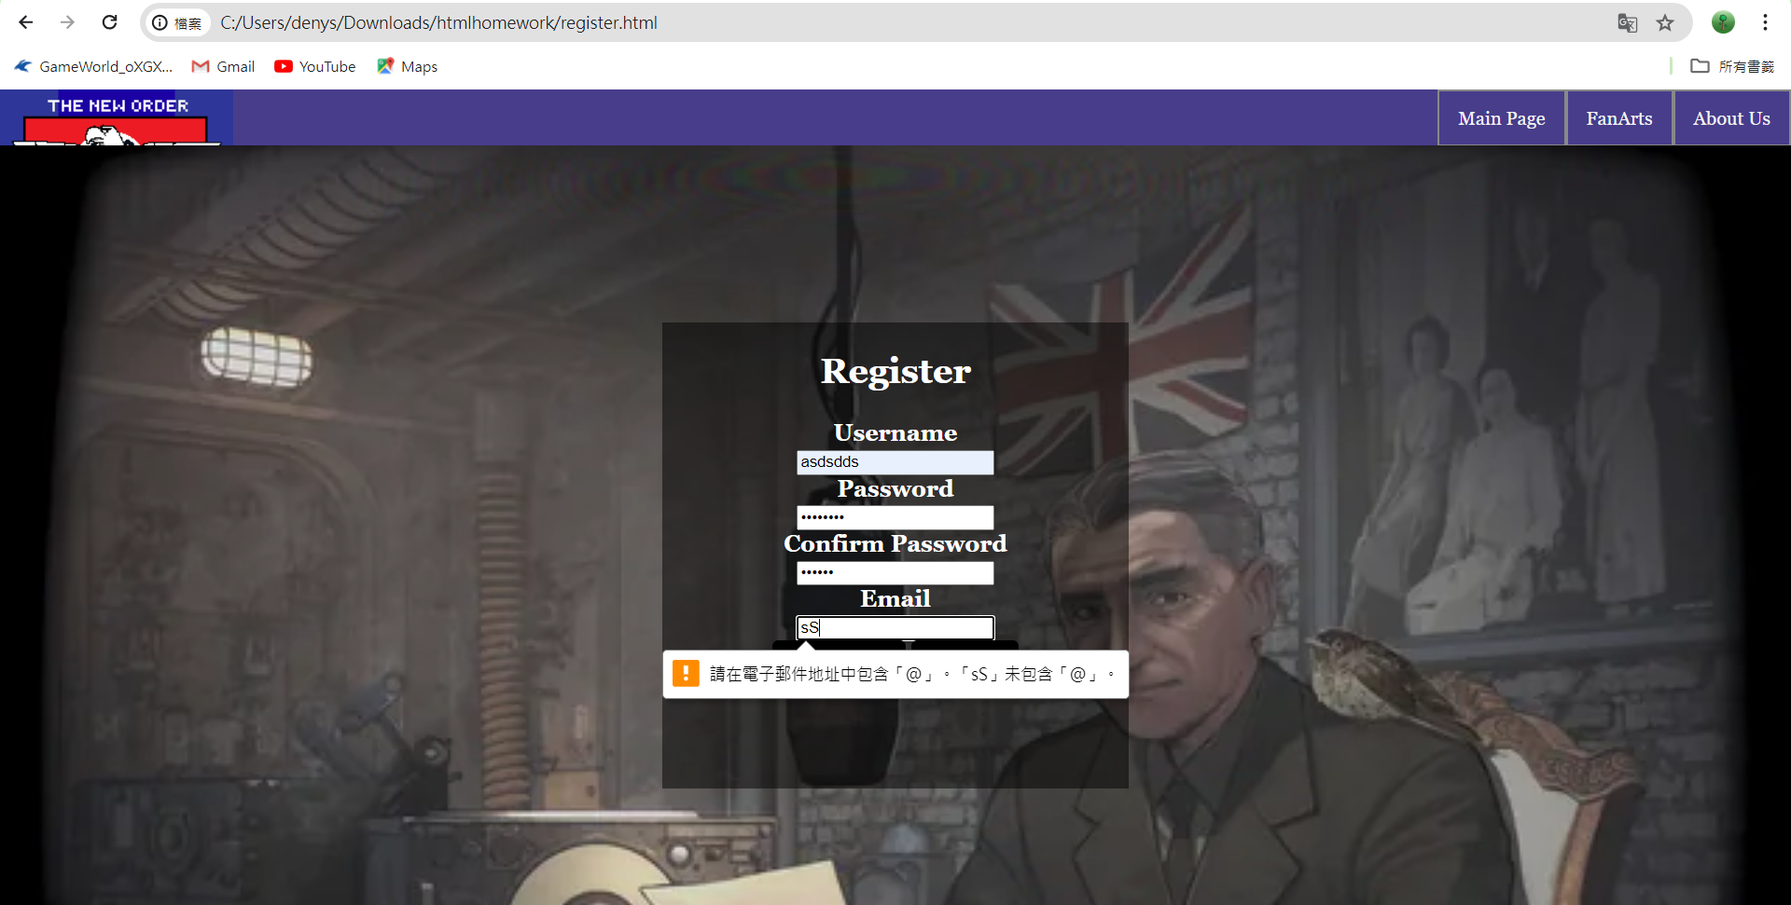

Not matched in the confirm password to password/other errors

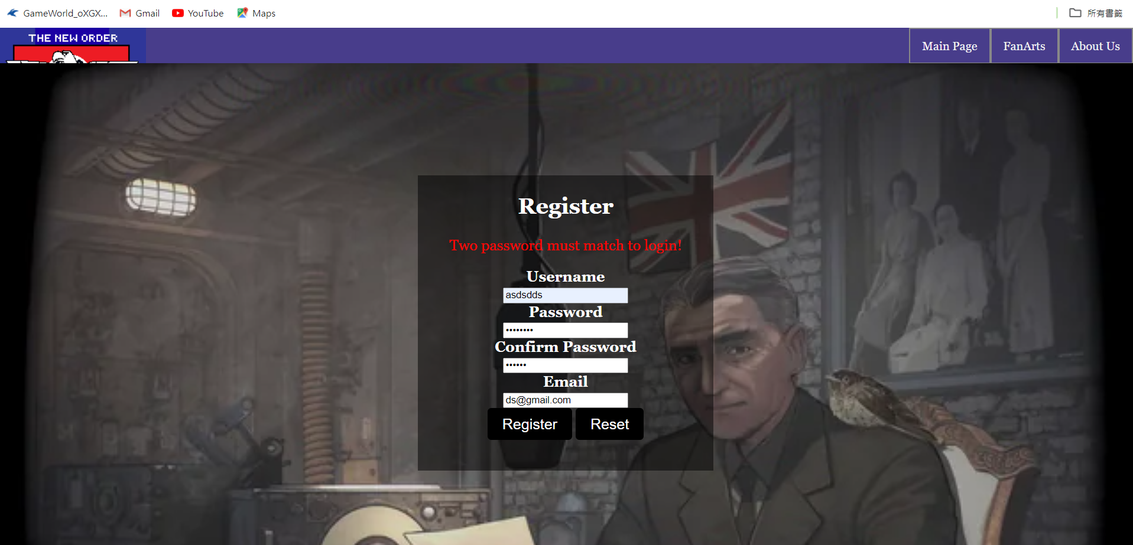

Hover on the buttons

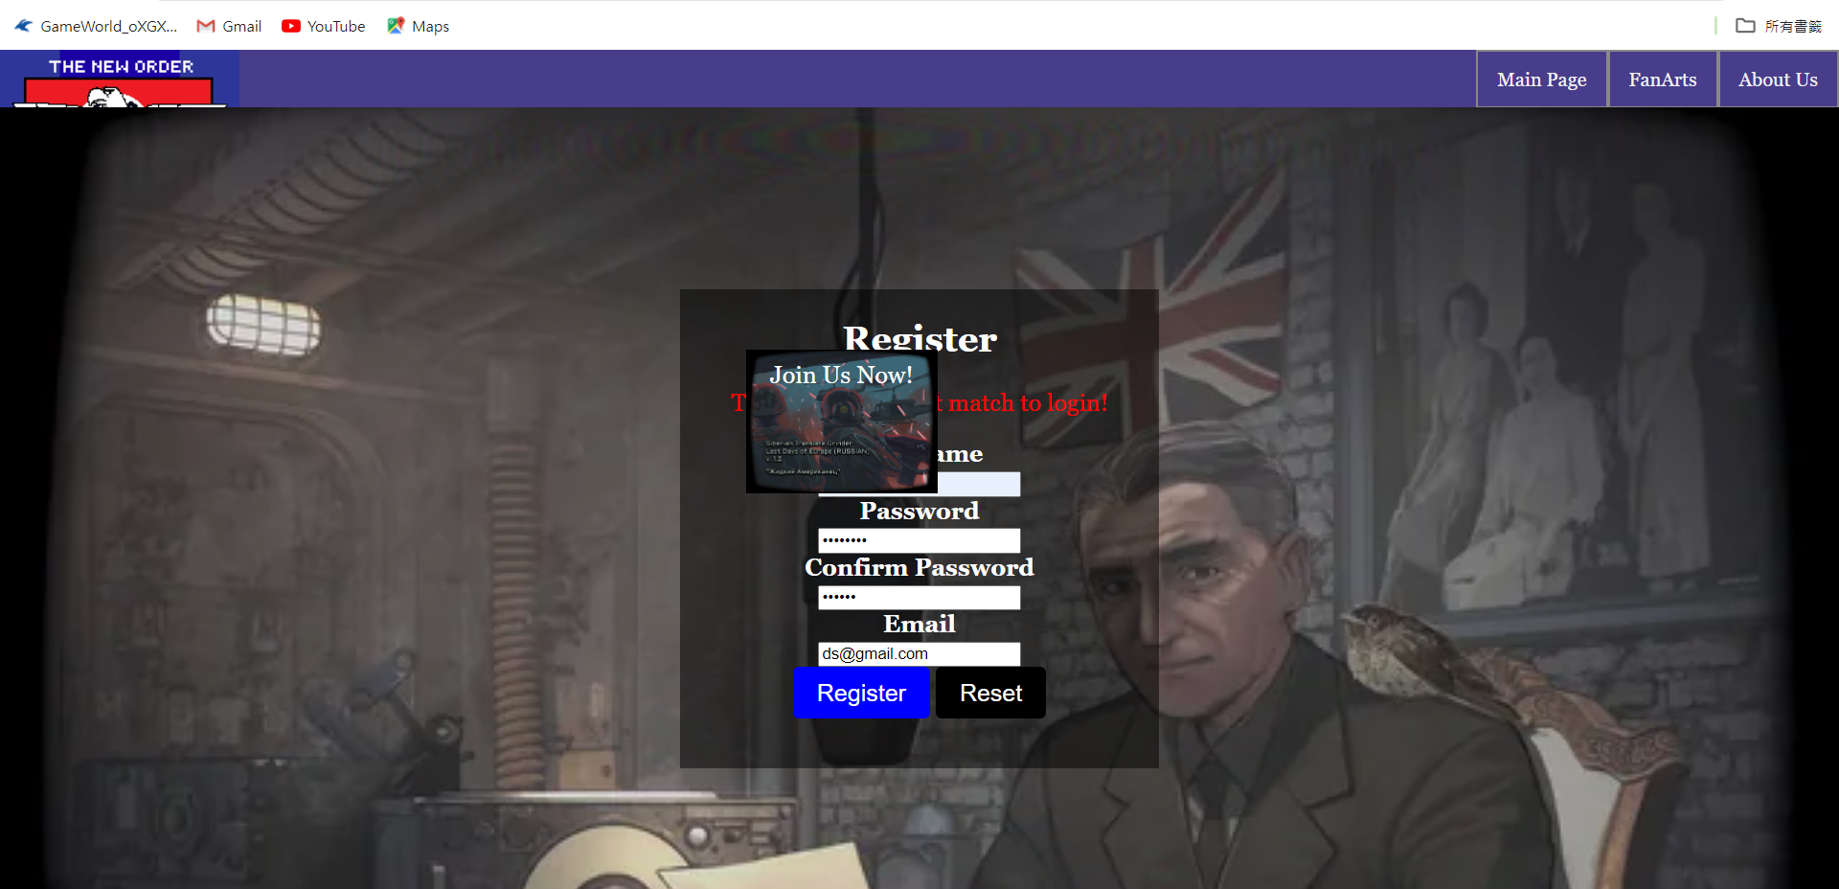

Jump to login page after success in 3 seconds

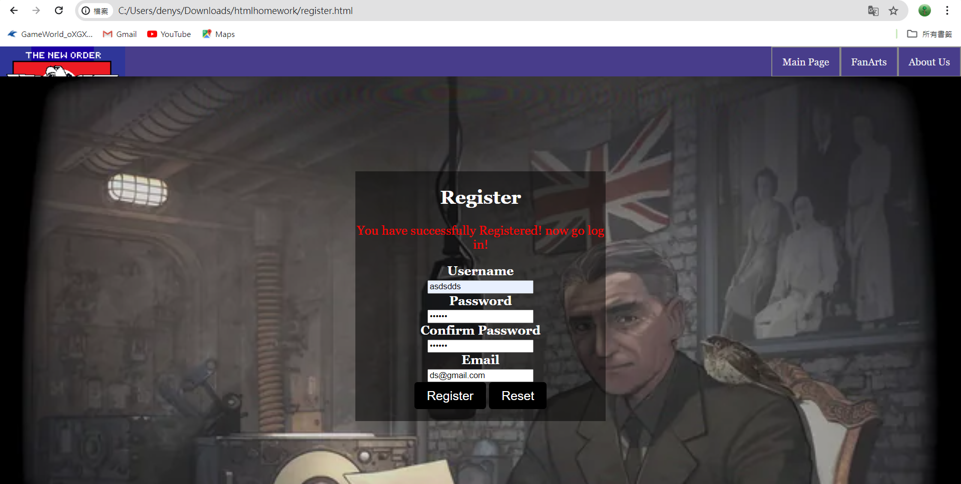

**Login Page does the same, but jump to the index.html**

**Fan art page**

This let the user take a look at fans artwork and can make them upload photo with mailto

